Artnet setup in Beyond
Last updated March, 2026

- Settings Tab> DMX > Click “DMX/ ArtNet Settings…” option
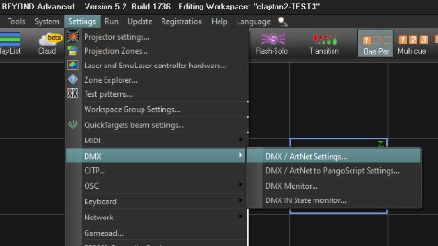

- Connection Tab> DMX Input> Double Click “DMX Input 1” option (do not select DMX Output)
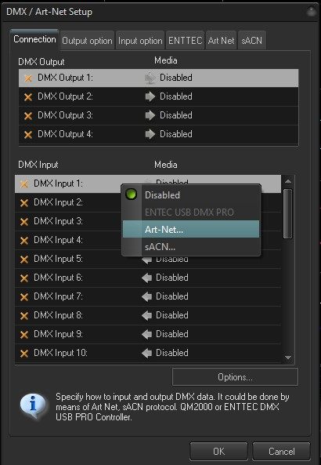

- The LD will tell you if they want to use ArtNet or sACN.
  - If sACN – Set this Universe – this must match the number in the lighting console. Most consoles like MA will send Multicast – then it doesn’t need to know the IP address of your Beyond PC’s dedicated ArtNet/sACN network adapter.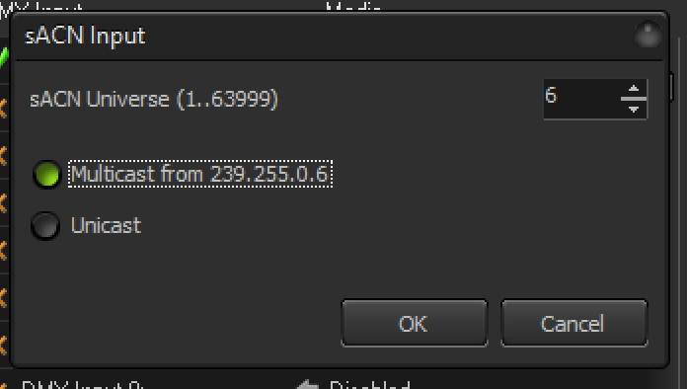

  - If ArtNet - Select ArtNet, and enter the Subnet and Universe (Note: Subnet AND Universe must match the console and will be provided by the LD; Since ArtNet technically starts with Universe 0, your number may be one less than the number the LD provides.) Also, there are 16 universes (of 512 channels each) in each subnet, so sometimes Universe 33 might be referred to as “Subnet 2, Universe 1”).
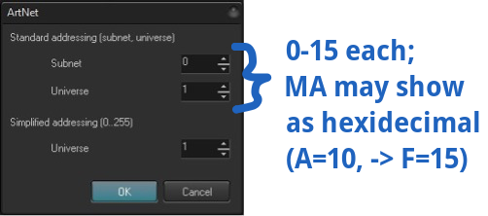
- Settings Tab> Click “Projection Zones…” option
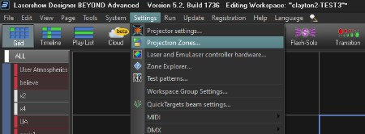

- Highlight the first projection zone
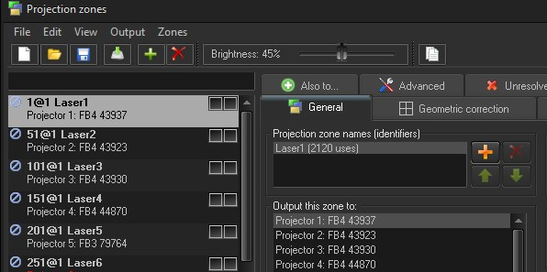

- Advanced Tab
- DMX Server> Select the mode that matches the profile from the console (Note: Mode must match the console and will be provided by the LD). It’s strongly recommended to only use the 32 channel Mid or 50 channel Max modes.
Safety Note: If an LD wants to use the FB4-style 39 channel profile, they need to be an LSO, carry the same insurance coverage that was required of you and agree in writing to take all liability and be the acting LSO. Why? Pangolin’s 39 channel profile doesn’t make this clear, but certain channel values (Ch1 = 240) will enter “Setup mode”, and then other channels can resize your zones’ Geo Correction.

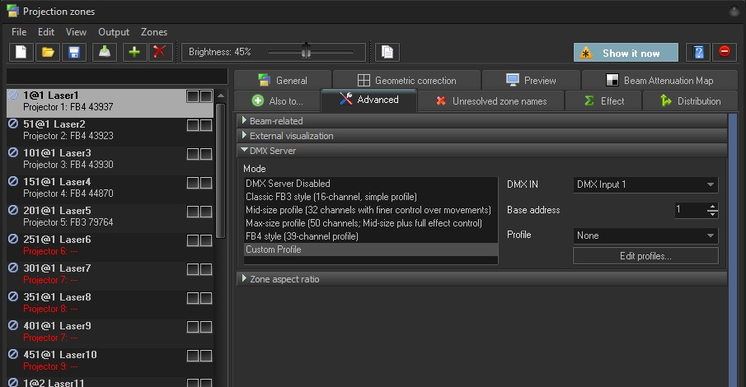

- DMX Input option will match the input option from step two

- Base address for the first projection zone will be 1 (all other base addresses will be in order - incrementally increasing in value as well as the corresponding projection zone). The increment by which you increase the base address value will be determined by the mode selected. For example: Projection Zone 1 will have a base address of 1.

- If 16 channel mode was selected, then Projection Zone 2 would have a base address of 17.
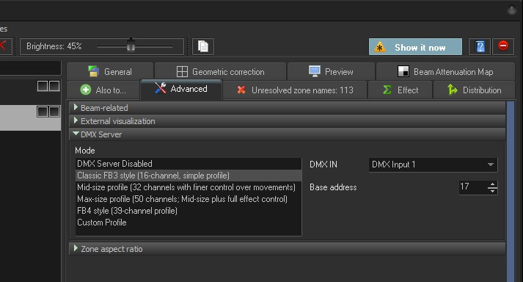

- If 32 channel mode was selected, then Projection Zone 2 would have a base address 33.
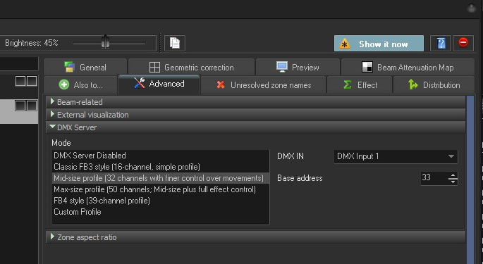

- If 50 channel mode was selected, then Projection Zone 2 would have a base address of 51.
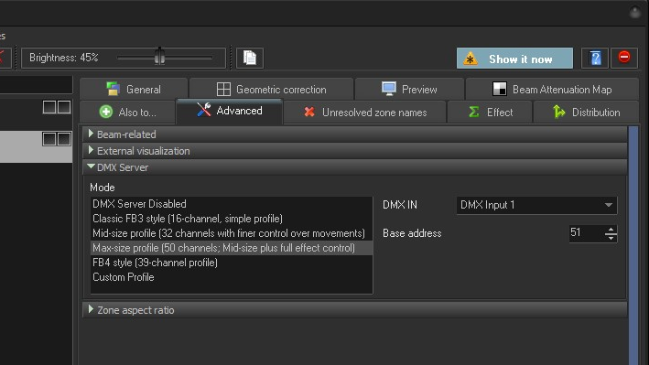

- If 39 channel mode was selected, then Projection Zone 2 will have a base address of 40. See important safety note above about 39-channel mode.
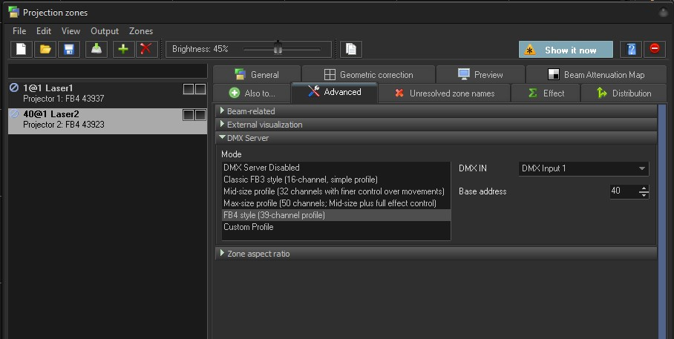
Notice how you’ll see the <DMX base address>@Universe now before the zone name.

- Here are some example addressing schemes:
32-channel profile
Contiguous
Zone | Base Addr
1 | 1
2 | 33
3 | 65
4 | 97
… | …
32-channel profile
Example of 32s spaced on 50s so different desks can use different size profiles on a changeover (you’d change the profile/mode for all zones, but not their addressing).
Zone | Base Address
1 | 1
2 | 51
3 | 101
4 | 151
… | …

12 projectors using 50-channel profiles
That’s 600 channels, but a DMX universe can only have 512 max, so they must be split across universes.
Art-Net input | Universe | Zone | Base Addr | Art-Net input | Universe | Zone | Base Addr
1 | 1 | 1 | 1 | 2 | 2 | 11 | 1
1 | 1 | 2 | 51 | 2 | 2 | 12 | 51
1 | 1 | 3 | 101
1 | 1 | 4 | 151
1 | 1 | … | …
1 | 1 | 10 | 451

Ultimately, you’re just agreeing with the various MA operators on what the addressing scheme will be.

- Recent versions of Beyond 5.5 (at least build 2024) have a helpful auto-addressing tool that can make this faster for large rigs. It’s found in the small icon that looks like a white/blue dialog box.
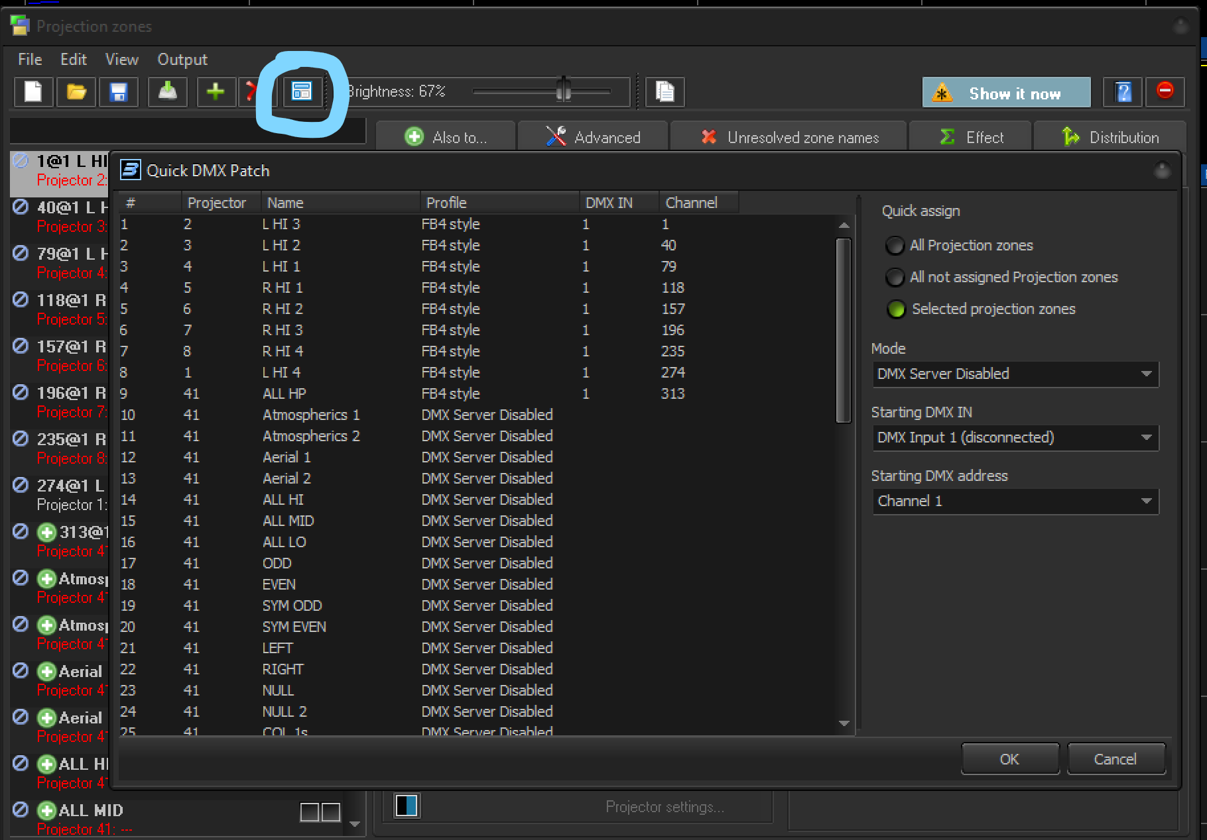

- View tab> Click “Show DMX/ArtNet channels monitor” option. This will open an extra window in between your main grid and QuickFX area that will allow you to see the live data coming from the lighting console through ArtNet/sACN.
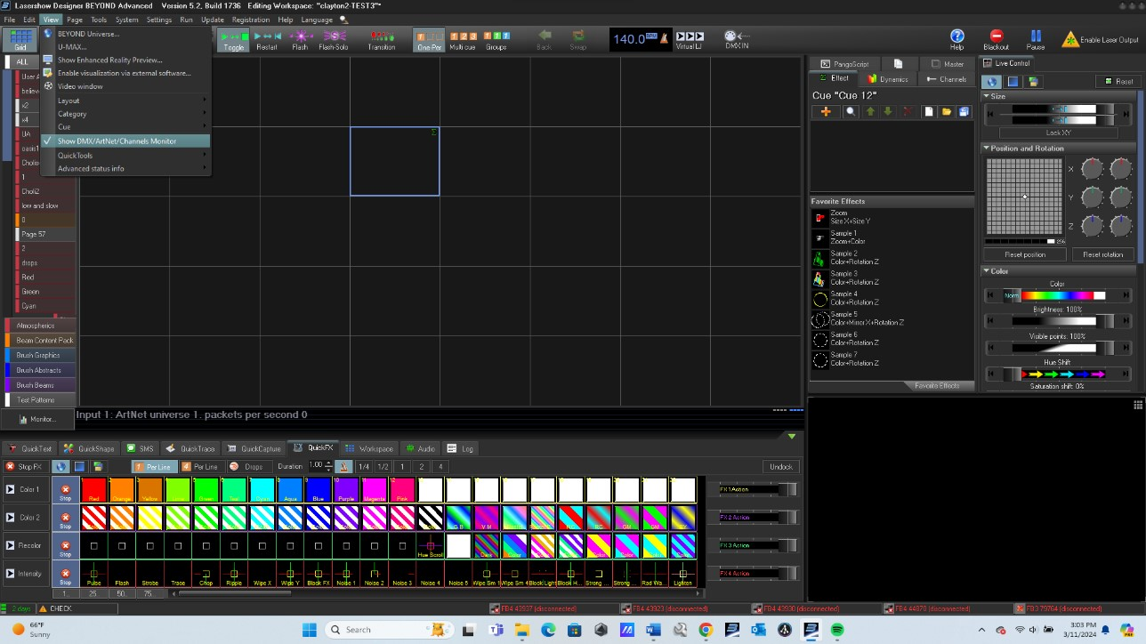
- Enable DMX input:
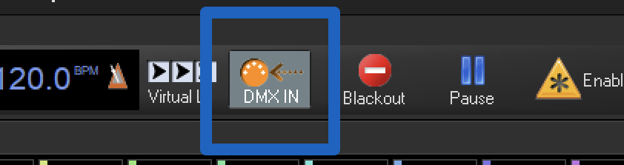

Ask the GrandMA operator to send laser data. Beyond is receiving if you see green bars in this area:
While you can also use Settings -> DMX -> Monitor, the tools discussed below (ArtNetominator and sACN View) are better because you can line up the corresponding channels for each laser.

Troubleshooting
Not receiving network data | Most of the time you need to assign your ArtNet ethernet interface a manually-assigned IP address. The console operator must tell you what IP and subnet mask to assign to the ArtNet ethernet port. If there’s no router between the Beyond PC and the MA desk, you can optionally use the lighting desk’s IP address as the gateway and DNS server.  Artnet is commonly on 2.X.X.X or 10.X.X.X and commonly uses a subnet mask of 255.0.0.0. This subnet mask is also sometimes called "slash 8" or "Class A”.  You should be seeing these numbers go up:  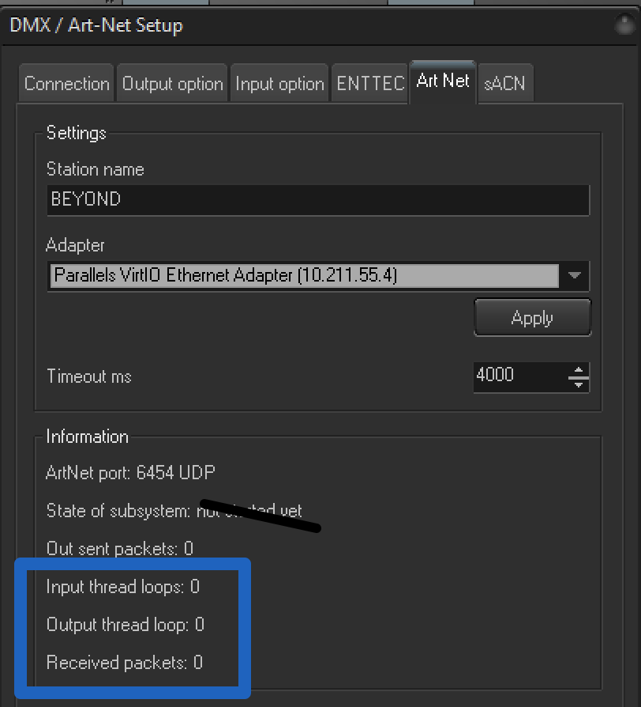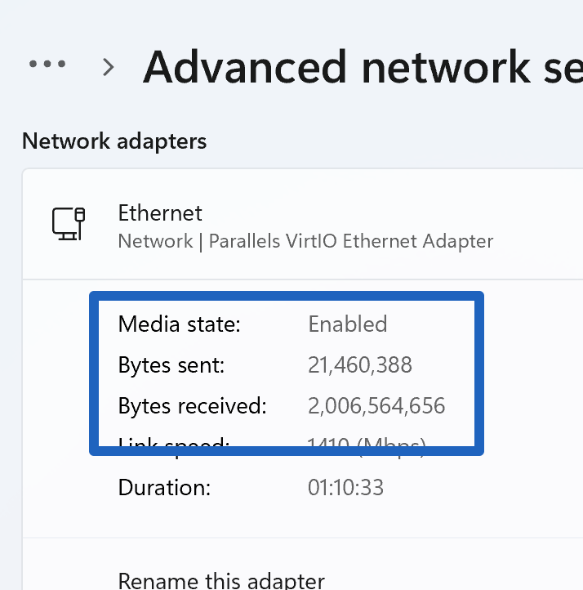  You should be able to ping the MA’s IP address (ask the MA operator for it).  If you have nmap and are connected directly to the desk, a GrandMA’s IP/MAC will show as a MA Technologies device.  C:\>nmap -sn <ip address>  Check that you’ve disabled Windows Firewall for this network.
Lasers get unreliable | Make sure you’re using a separate ethernet interface/dongle for ArtNet vs FB4 data.  Make sure the correct one is selected for ArtNet:  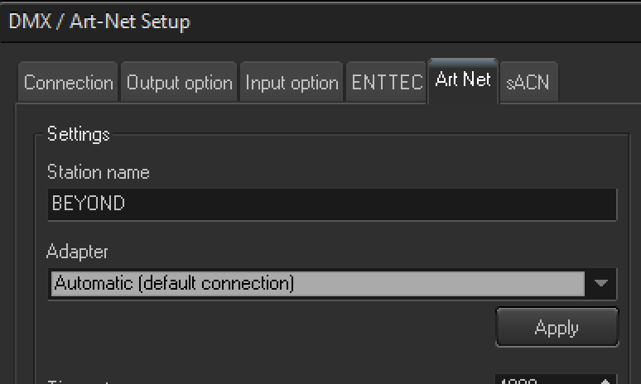  or:  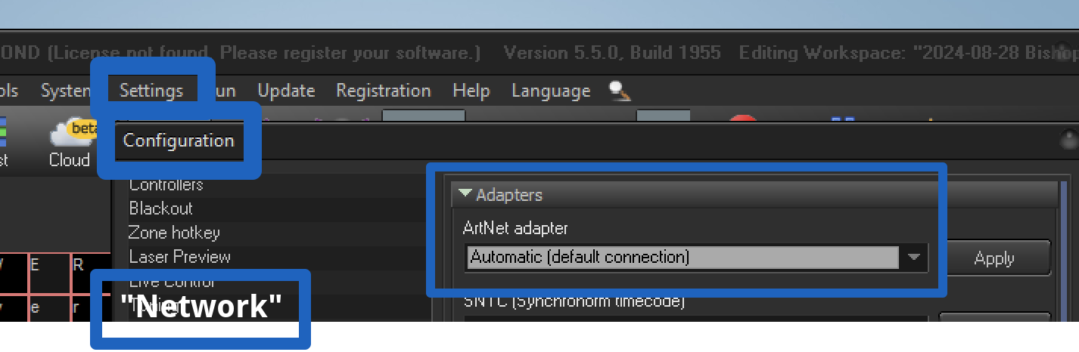  Your ArtNet subnet should not conflict (overlap) with any others on the computer. For example, if the venue WiFi is giving you 10.50.1.183, or you have manually-assigned laser IPs on 10.1.1.<Projector#> and the lighting desk wants you to be 10.5.1.70 – expect problems. Use AI to figure out if subnets overlap.  Note that the private class B is commonly safe to use and has the least potential for conflicts on other networks. These addresses start with 172.16.X.X and can use a subnet mask of either 255.255.0.0 or 255.240.0.0.
Network is good, but I can’t see incoming data on the universe I was given. | Download a free app called The ArtNetominator. It’s intuitive and can help you quickly find exactly what universes are unicasting directly to you or being broadcast to all devices on that network (in which case it may be harder to isolate exactly which universe is meant for you). If using sACN (E1.31), sACNView is similar.

Official Pangolin guides
- Beyond DMX Settings PDF guide
- DMX Setup videos Part 1 Part 2 (Part 3 covers uncommon stuff)

